
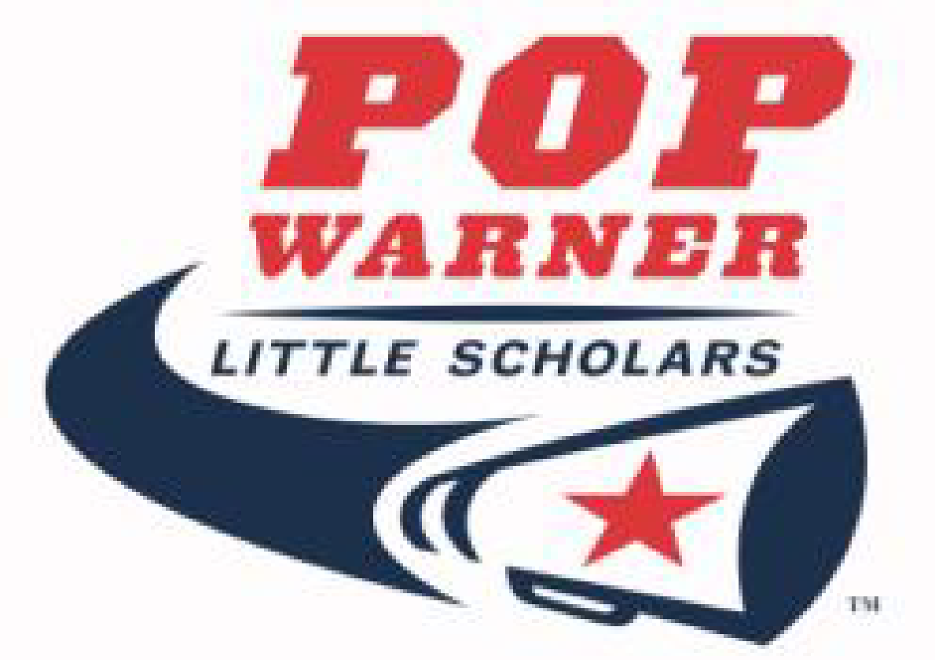
The Billy Nicolas Football Scholarship
In Memory of Coach Tommy Lynch
Presented by the North Rockland Youth Football & Cheer Association
Application MUST be mailed to P.O. Box 331 Garnerville, NY 10923 no later than April 5th,2022

North Rockland Youth Football & Cheer will award a scholarship(s) of $500 to a senior graduate(s) who plans to attend a junior college, college or university and meets the following qualifications:
- Applicant must have played at least two (2) years for North Rockland Youth Football & Cheer and
- Applicant must have played two (2) or more years for their high school or volunteered as a trainer or student demonstrator for North Rockland Youth Football & Cheer for at least two (2) years.

Complete the following information if you meet the qualifications stated above.
Name: Date of Birth:
Telephone #: Email Address:
Home Address: City:
Parent/Guardian Name(s):
College/University applied to/attending:
# of years in NRYF&C program: Coaches’ Name(s): ______
# of years as NRYF&C volunteer: Specify Role:
# of years participation in HS football: (grades 9 – 12 only)
All County, All League or 1st Team Recognition:
SAT Scores (highest): Math Verbal Writing
Current GPA: ACT Score (if applicable):
Extracurricular Activities:
Local Honors (e.g., Honor Roll)
National Honors (e.g., National Honor Society, Science, Math, etc.)
Community Service (e.g., Charity, Ambulance Corps, etc.)

A copy of SAT/ACT scores and school transcripts must be attached. School transcripts must be signed by the Guidance office. Failure to do this will disqualify applicant from consideration.

